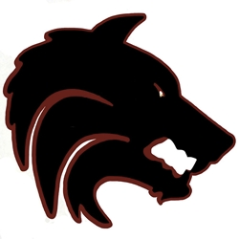
Desert Mountain Volleyball 2014
Student Athlete Personal Ad

All Personal Ads are due by Monday, September 8th

Ad includes 1/4 page, two photos and personal message to athlete for $30

Please email the information below to dmhsvolleyball@cox.net
Please also email two photos of your athlete! Please include subject: DMVB Ad

Athlete Information
Name: Phone:
Team:
Email:

Message to Athlete (limit 20 words)

PAYMENT INFORMATION
Payment questions: Please contact Colleen Branch at (480) 229-8447 or cbranch@q.com. Please make checks payable to DMVB Boosters and mail to Colleen Branch - 13250 N. 102nd Place, Scottsdale, AZ 85260 OR hand in payment to Coach Neal

